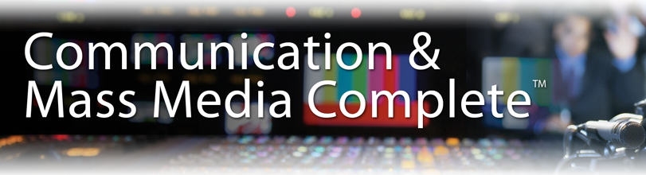
- Communication and Mass Media Complete大众传媒学全文数据库
CMMC提供传媒相关领域最全面、质量最佳的研究解决方案。 CMMC 整合 CommSearch (之前由 National Communication Association 制作) 与 Mass Media Articles Index (之前由 Penn State 制作) 及其它数种与大众媒体及其相关研究领域的期刊，共同建立一个囊括广泛的传播领域所需的研究与参考资料来源，范围之大与内容之深入前所未有。其内容涵盖传播学、广告学及语言沟通相关领域的主题，收录近1300种期刊的索摘，其中430多种全文期刊。另外还收录了133种书籍专著，24,000多份会议论文以及5,500多份作者背景介绍。内容主要来自美国传播协会(National Communication Association)的CommSearch数据库及美国宾州州立大学的Mass Media Articles Index数据库。
数据库专业涵盖：新闻学，传播学、语言学，修辞学，语言病理学，沟通原理，媒体研究等。
CMMC内的全文期刊，仅有41本是收录在Academic Search Complete中，43本是收录在Academic Search Ultimate中。换言之，CMMC中90%的全文内容并没有收录在EBSCO其它数据库内。此数据库是新闻学院、外语学院、教育学院必备的电子文献之一。
数据库中期刊最早回溯至1915年，每月更新。
收录的知名期刊举例如下: Communication Education, Communication Monographs, Critical Studies in Media Communication, International Journal of Corpus Linguistics, Journal of Applied Communication Research, Journal of the Association for Communication Administration, Philosophy & Rhetoric, Quarterly Journal of Speech, Sign Language & Linguistics, Text & Performance Quarterly等.
同时，许多同行评审全文期刊有较长的回溯，如American Speech (1925至今), Communication Disorders Quarterly (1978至今), Communication Education (1976至今), Communication Monographs (1976至今), Communications: European Journal of Communication Research (1975至今), Folia Linguistica (1967至今), International Journal of Language & Communication Disorders (1965至今), International Journal of the Sociology of Language (1976至今), Journal of Business Communication (1963至今), Journal of Technical Writing & Communication (1971至今), Philosophy & Rhetoric (1968至今)等.
- 传媒学相关的顶尖全文期刊
- Western Journal of Communication (1937 to present)
- Quarterly Journal of Speech (1928 to present)
- Modern Language Journal (1916 to present)
- Communication Quarterly (1953 to present)
- Communication Monographs (1934 to present)
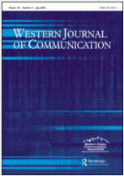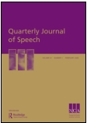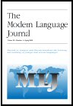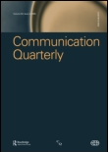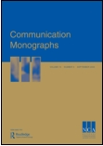
- 翻译相关的顶尖全文期刊
- Studies in Translation
- Target: International Journal on Translation Studies
- Interpreting: International Journal of Research & Practice in Interpreting
- Translation Studies
- Linguistics & the Human Sciences
- RaeL: Revista Electronica de Linguistica Aplicada
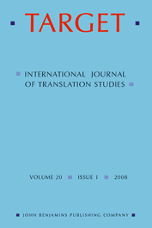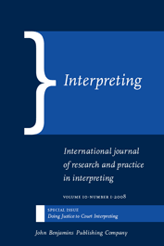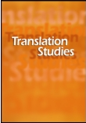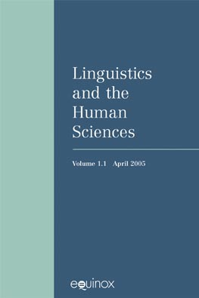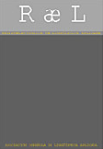
- 语言学相关的顶尖全文期刊
- Australian Journal of Linguistics
- Clinical Linguistics & Phonetics
- International Journal of Corpus Linguistics
- IRAL: International Review of Applied Linguistics in Language Teaching
- Linguistics & the Human Sciences
- Linguistics in the Netherlands
- South African Journal of Linguistics
- International Journal of American Linguistics
- International Journal of Applied Linguistics
- Journal of Quantitative Linguistics
- Probus: International Journal of Latin & Romance Linguistics
- Sign Language & Linguistics

